**“Car Game”**

**MINOR PROJECT SYNOPSIS (KCA-353)**

**SUBMITTED TO**

**DR. A.P.J. ABDUL KALAM TECHNICAL UNIVERSITY, LUCKNOW(U.P.)**

**FOR THE PARTIAL FULFILLMENT OF THE DEGREE OF MASTER**

**IN COMPUTER APPLICATION SESSION (2nd Year)**



**Under the Guidance of: Submitted by:**

Ms. Jyoti Tripathi **Mohit Singh**

Assistant professor **(2100980140029)**

School of IT

IMS-Noida

**INSTITUTE OF MANAGEMENT STUDIES, NOIDA**

**PROFORMA FOR APPROVAL OF THE MCA MINI PROJECT (KCA-353) PROPOSAL**

**1.Roll No**:. 2000980140001 & 200098014005

1. **Name of the students:** Abhinav Adarsh & Aniket Anand
2. [**E-mail**: abhinav.adarshmca2021022@imsnoida.com ,](mailto:chandrika.rawatmca2021008@imsnoida.com) [aniket.anadmca2021004@imsnoida.com](mailto:aniket.anadmca2021004@imsnoida.com)

**4. Mob. No:-** 8229011661 ,7903717640

1. **Title of the MINI Project (KCA-353):** E-commerce
2. **Name of the Mentor:** Mr. Pankaj Agarwal



Approved NotApproved

Signature of the Mentor Date:

**INDEX**

|  |  |  |  |  |  |
| --- | --- | --- | --- | --- | --- |
| **S. No** | | **Particulars** | **Page No.** | **Date** | **T. Sign** |
| **1** | | **Cover And Title Page** | **1** |  |  |
| **2** | | **Synopsis Approval** | **2** |  |  |
| **3** | | **Index** | **3-4** |  |  |
| **4** | | **Acknowledgement** | **5-6** |  |  |
| **5** | | **Certificate of Originality** | **7** |  |  |
| **6** | | **Introduction/Aims and Objective)** | **8-9** |  |  |
| **7** | | **System Analysis** | **10-14** |  |  |
| **8** | | **Feasibility Study** | **14** |  |  |
| **9** | | **Analysis ( DFD 0 Level,)** | **15-16** |  |  |
| **10.** | | **S/W Engineering paradigm applied** | **17** |  |  |
| **11.** | | **S/W & H/W Requirement Specification** | **17** |  |  |
| **12.** | | **System Design** | **17** |  |  |
| **13.**  **14** | | **Screen shots**  **Coding** | **18**  **19-29** |  |  |
| **15** | | **Validation Checks** | **29-30** |  |  |
| **16** | | **Implementation and Maintenance** | **30-32** |  |  |
| **17** | | **Testing** | **32-33** |  |  |
| **18** | | **System Security measures** | **34-36** |  |  |
| **19** | | **Various types of Reports/Modules** | **36-37** |  |  |
| **20** | | **Pert Chart/Gantt Chart** | **37** |  |  |
| **21** | | **Future scope of the Project** | **38** |  |  |
| **22** | **Bibliography/References/Glossary** | | **38** |  |  |
|  |  | |  |  |  |

## ACKNOWLEDGEMENT

I am very grateful to my Mini Project (KCA-353) Mentor Mr. Pankaj Agarwalfor giving her valuable time and constructive guidance in preparing the Synopsis/Mini Project (KCA-353). It would not have been possible to complete this Mini Project (KCA-353) in short period of time without her kind encouragement and valuable guidance.

Date:22/11/21

**Signature**

**Name of the Student**

Abhinav Adarsh

## ACKNOWLEDGEMENT

I am very grateful to my Mini Project (KCA-353) Mentor Mr. Pankaj Agarwalfor giving her valuable time and constructive guidance in preparing the Synopsis/Mini Project (KCA-353). It would not have been possible to complete this Mini Project (KCA-353) in short period of time without her kind encouragement and valuable guidance.

Date:22/11/21

**Signature**

**Name of the Student**

Aniket Anand

**Certificate of Originality**



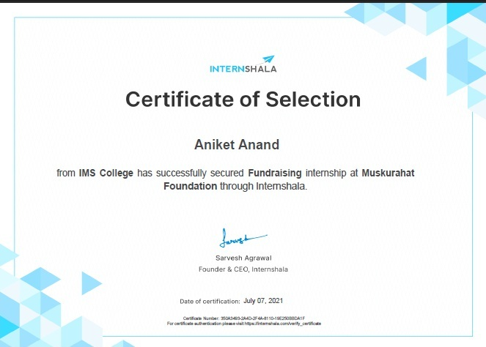

**Introduction/Aims and Objective**

**E-Commerce – Introduction**

* **E-commerce** means using the Internet and the web for business transactions and/or commercial transactions, which typically involve the exchange of value (e.g., money) across organizational or individual boundaries in return for products and services. Here we focus on digitally enabled commercial transactions among organizations and individuals.
* E-business applications turn into e-commerce precisely, when an exchange of value occurs. Digitally enabled transactions include all transactions mediated by digital technology and platform; that is, transactions that occur over the Internet and the web.
* E-tailing is a subset of e-commerce, which encapsulates all “commerce” conducted via the Internet. It refers to that part of e-commerce that entails the sale of product merchandise and does not include sale of services, namely railway tickets, airlines tickets and job portals.
* Even popular social networking sites like Facebook(dot)com are allowing people to promote and sell products and services online and the introduction of computer and mobile based e-commerce application software like Shopify provides evidence of how e-commerce have boomed over the past 5 years.

**E-Commerce – Objectives**

* **Development of Business-Relationship:**

The business development can be done through the e-commerce being the primary and the basic object. As their direct contact in between the company and the consumer, their business relationship will be enhanced. Hence the area of the market can be increased.

* **Better-Customer Service:**

As it is done round the clock, the customer will always have online help regarding the products. As all the information is furnished to the customer, it becomes easy to him to choose the best product among all other alternatives. As even the service can also be done through the net immediately, the customer service will be ballooned. By highlighting the customer service, the companies are trying to subjugate a lion-share in the market.

* **Getting more Customers:**

In these days it becomes the mandate of the companies to double its customers, and this can be done by rendering the value add service and maintaining the quality. Hence, it is also one of the primary objectives of the companies which supply impetus for the robust growth in sales and overall profit.

1. **System Analysis**

**7.1 Identification of Need**

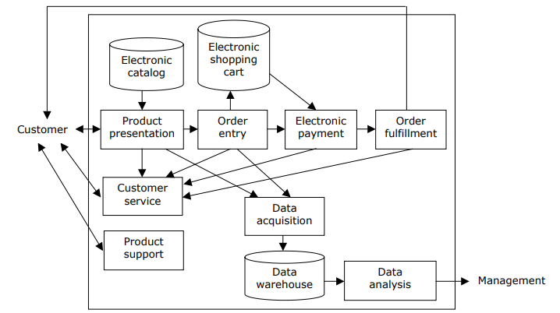

Figure 1. E-commerce system model

* **Product presentation-**

The product presentation function provides the customer with information about the product through the user interface (browser). The information presented can include:

* + Product advertisements, including product descriptions and features
  + Detailed product specifications
  + Product views, including photographs, diagrams, or other two-dimensional images; three-dimensional views; single or multiple views; moving or animated views; rotating views, perhaps under customer control; and figure models (e.g., for apparel)
* **Order entry-**

The order entry function allows a customer to place an order for selected products. Information about each product ordered is added to the electronic shopping cart, which is a database of orders in process. One characteristic of this function is the effort (e.g., number of mouse clicks) required by the customer to order an item. This function is linked to the enterprise's inventory system in order to check product availability.

* **Electronic payment-**

The electronic payment function provides the capabilities for the customer to pay for the order and thus complete the transaction. Payment options may include credit card, debit card, COD, check (before delivery), and invoice (after delivery). In B2B transactions, electronic funds transfer (EFT) may be a payment option. As with order entry, a characteristic of this function is the effort required by the customer to complete the transaction. Security is very important in the electronic payment function. The function should provide the necessary security through SSL, SET, or some other protocol, and customers should be apprised of the security provisions.

* **Order fulfillment-**

The order fulfillment function provides for the delivery of the product to the customer. The delivery can be digital for products such as music, software, and information. Only physical delivery is possible, however, for many products such as apparel, electronics, and manufacturing components. This function is linked to the enterprise's inventory system so that the inventory database can be updated when the order is fulfilled. For physical delivery, the function is linked to the enterprise's warehouse and shipping systems.

* **Customer service-**

The customer service function provides assistance to customers who have problems or questions related to the purchasing process. This assistance may be needed before, during, or after a purchase, as illustrated in the following examples:

* + Before purchase: questions occurring during use of the product presentation function, such as product features or use.
* **Product support**-

The product support function provides assistance to the customer related to the product after it has been received. This support may include initial set-up and installation, regular operation, troubleshooting, on-going maintenance, and warranty or non-warranty repair or replacement.

* **Data acquisition-**

The data acquisition function captures data during the customer interaction with the system. Some of the acquired data, such as customer identification and credit data, is stored in the enterprise's customer database. Much of the acquired data, however, is stored in a separate data warehouse. This data includes customer preferences and purchasing decisions. Customer preferences data could be acquired from the product presentation function.

* **Data analysis-**

The data analysis function analyzes the data in the data warehouse. Data mining techniques are typically used for this purpose in an effort to identify trends, relationships, and other useful information. The results of the analysis can be used by management for decision making in many areas, especially marketing.

* 1. **Preliminary Investigation**

Electronic or e-commerce (EC) has dramatically changed the manner in which inter- and intra-organizational transactions are conducted. It is further argued that the advent of EC has changed the trading and buying social culture. The present research investigates ninety five small and medium business organizations of various business types in Brunei Darussalam.

The study has assessed EC adoption and found that 65% of the organizations have claimed to adopt EC. Several of the adoption attributes such as relative advantages, compatibility, trialability, observability, and organizational attributes such as nature, size, and type of business were studied along with managerial attributes: management support and top management attitudes towards EC adoption.

The study has concluded that adoption parameters such as, compatibility with others, trialability and observability along with management support and top managers' attitudes were found to be the major determinants of EC adoption. Results are discussed and some implications for the management are made.

1. **Feasibility Study**

**8.1 Technical Feasibility**

It involves development of a working model of the product or service. It is not necessary that the initial materials and components of the working model represent those that actually will be used in the finished product or service. The purpose of the working model is to demonstrate, to your own satisfaction, that the product or service is functional and producible. It also provides a visual means to share your concept with others.

The concept of a mechanical working model is easier to grasp and understand than software, e-commerce or service-related products. E-commerce models require verification of the ability to integrate the computers, servers, software and programming needed to support the operational concept. Services, packaged as a set of value-added activities, should deliver observable benefits.

* 1. **Economic Feasibility**

The Economic Feasibility model for each category of Electronic Commerce System is going to be derived considering the subsystems in each categories namely (i)B2C (ii)B2B (iii)C2B (iv) C2C. In general the Economic Feasibility depends on the Return On Investments (ROI) derived, based on the cost savings generated due to the difference between the Investments and the corresponding cost benefit achieved through the System.

* 1. **Operational Feasibility**

Operational feasibility is mainly concerned with issues like whether the system will be used if it is developed and implemented. Whether there will be resistance from users that will effect the possible application benefits.

# Analysis ( DFD 0 Level, 1- Level and 2 Level/ER Diagram, and Data structure, Table structure).

**A simple list**

The simplest solution is to have a single Form, called, say, 'Product', in which each product is described one per record.

This works well for very small numbers of products.

**Introducing categories**

Where there are more products, you will want to introduce categorisation. You provide a separate Form, called, say 'Category', and then provide a Record Link field on the Product form to allow you to place each product in a category.

You then create an interface that allows the visitor to browse through the categories, seeing lists of products, and then open a page on the particular product.

**Multiple category membership**

If you have products which can be in several categories at the same time, you can use a Multi-Record Link field, to allow relationships to be described.

You have the option of placing this field in the Category form, or in the Product form. This choice will depend on how you envisage the catalog being managed, but will have no effect of the final functionality or appearance.

**Product options**

In some cases you need to offer options (size, color, etc) for a given product. The main issue to consider here is whether the options are in effect creating a collection of separate (albeit similar) products, or whether you want to consider it simply as a single product.

Factors which will need to be considered (and would lead towards you treating each option as a separate product) include:

* Price variation between options
* The need for individual stock control of options.

**ER Diagram**

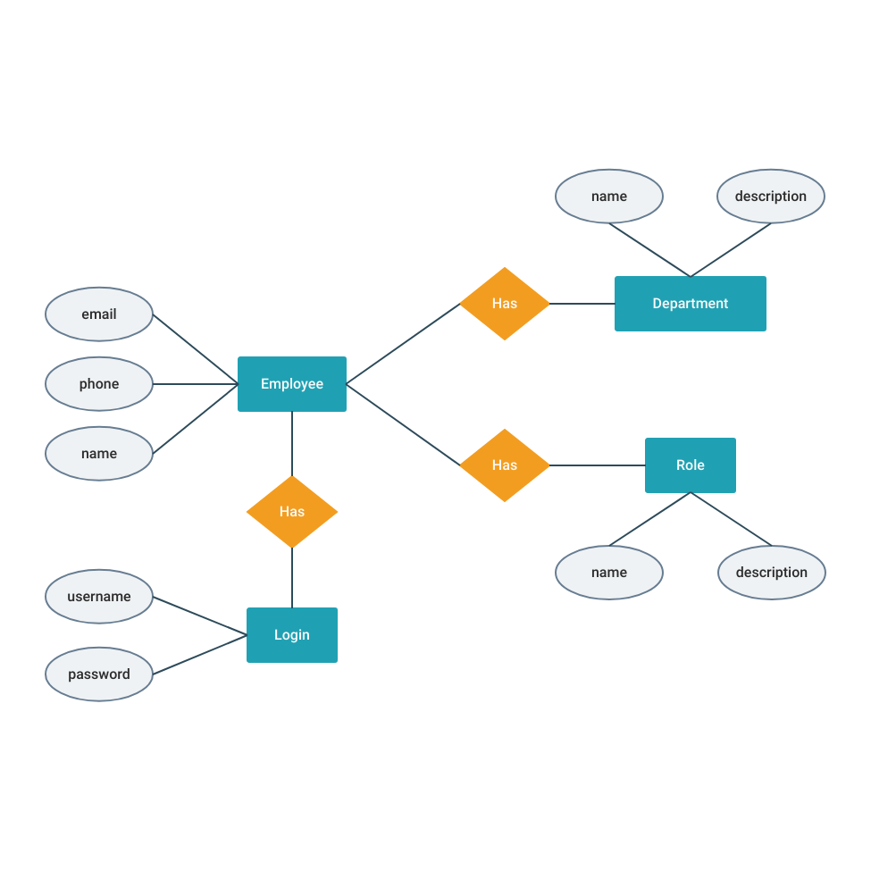

## S/W Engineering parading applied

## 1 One of basic software Engineering principle is Better Requirement analysis which gives a clear vision about the project. At last a good understanding on user requirements provides value to it’s users by delivering a good software product which meets user’s requirements

## 2 All designs and implementations should be as much simple as possible means KISS (Keep it Simple, Stupid) principle should be followed. It makes code so simple as a result debugging and further maintenance becomes simple.

## S/W & H/W Requirement Specification

* **Hardware Requirement for E-commerce**-

Pentium II/III based Intel server running Linux can serve hundreds of unique customers each day. Low traffic sites can be easily served from a single machine depending on the needs of the business. High traffic sites require a backup of servers which automatically takes over operations in case of failure of primary ones.

* **Software Requirements for E-commerce**-

Several software are available free on the internet that can be used to build e-commerce exchanges. Ex:- Linux OS, MySQL database ,Apache web server etc.

1. **System Design**

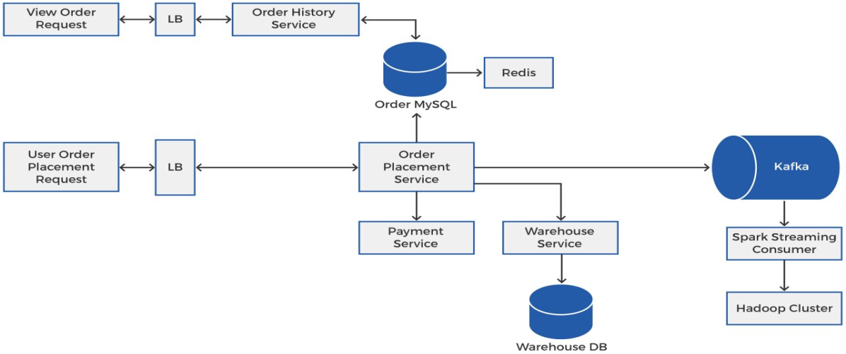

1. **Screen shots-**

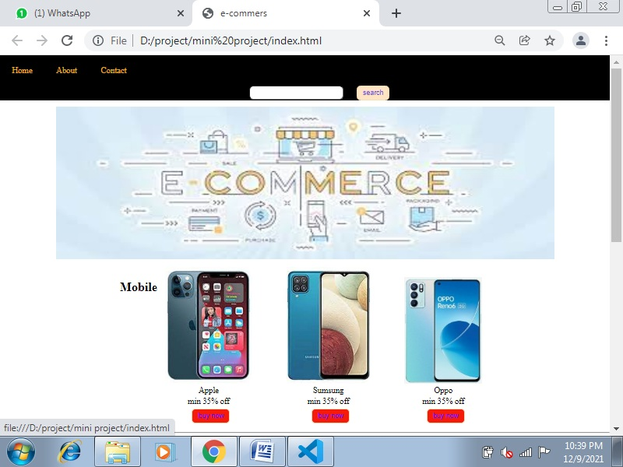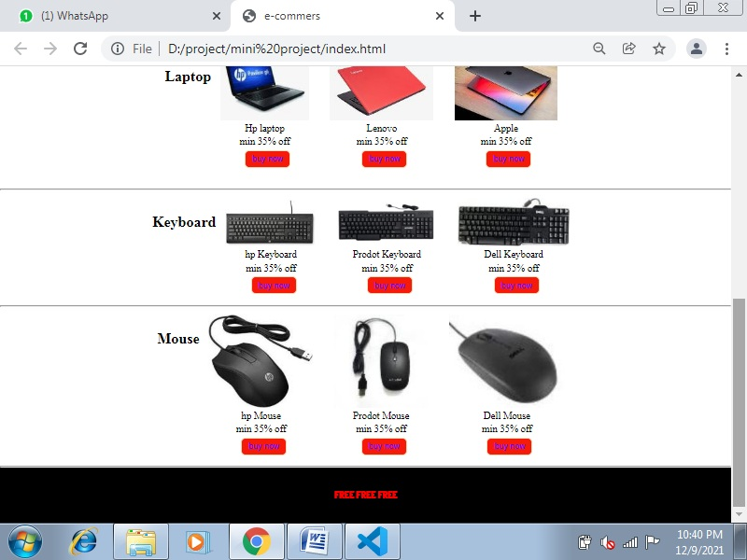

## Coding-

* HTML

In short, yes. HTML is very easy to learn. While it is code, and while it may seem daunting to you at first, you don't need to have any kind of programming experience. HTML isn't nearly as hard to learn as you might think

## 1.jpg

## 2.jpg

## 3.jpg

## 4.jpg

## 5.jpg

## 6.jpg

## 7.jpg

## 8.jpg

## 9.jpg

## 10.jpg

## 11.jpg

## 12.jpg

## 13.jpg

### **JavaScript**

Thanks to its dynamic capability and versatility, JavaScript has become the most popular and best programming language for eCommerce sites. The main peculiarity of this language is that it’s supported by most web browsers. JavaScript can be used for both back end and front end eCommerce development. It comes with many modules and libraries that enable you to develop almost any feature.

### **CSS**

CSS is another E-Commerce programming language that’s worth considering in this article. It helps you create your eCommerce website’s look by manipulating texts, headings, pictures, colors, and other web design elements. It is particularly useful for the development of the website layout and structure.

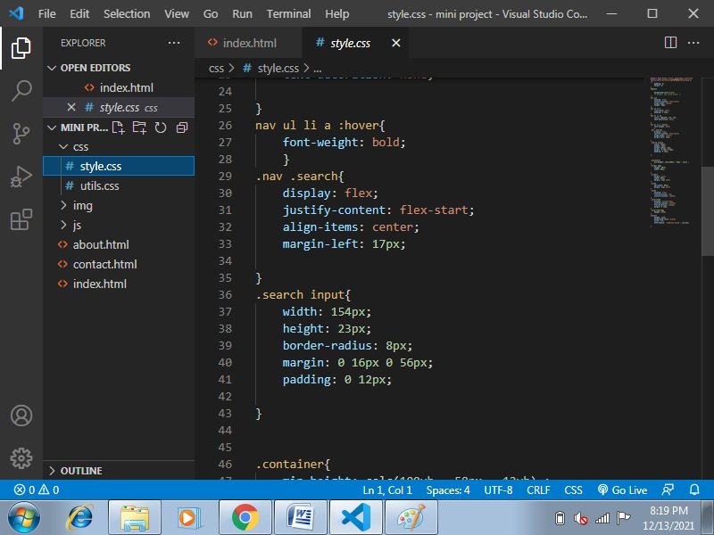

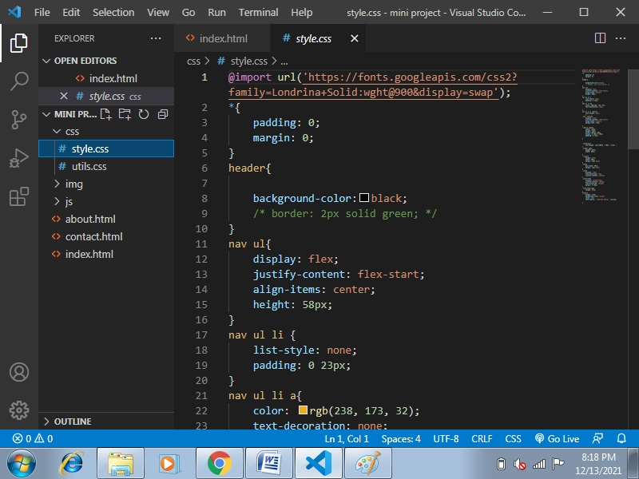

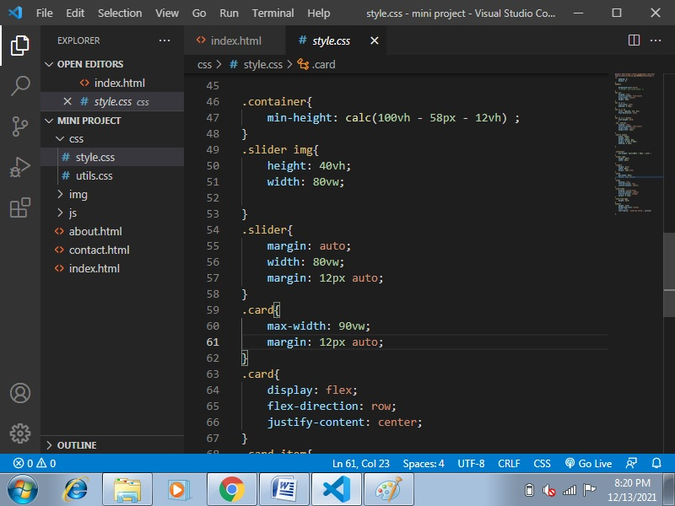

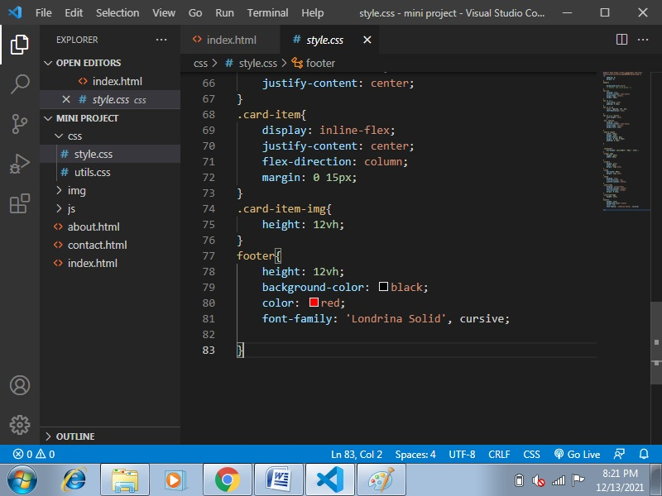

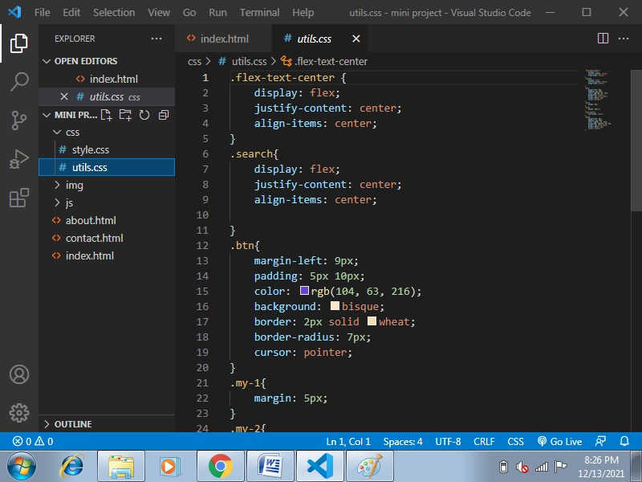

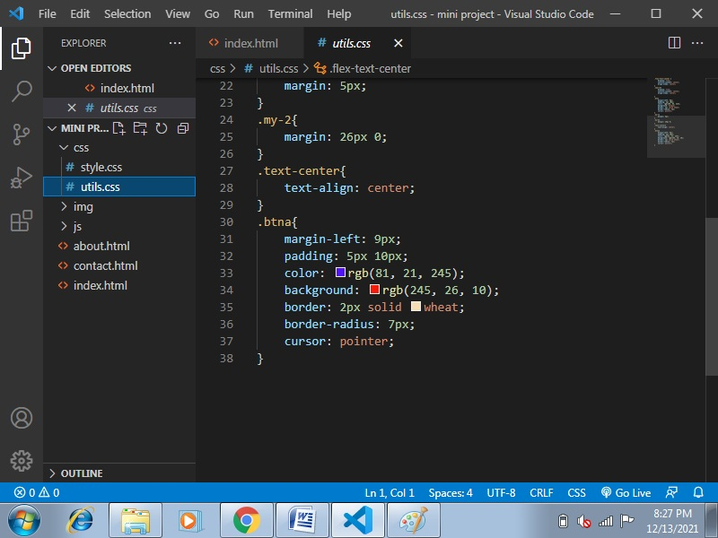

1. **Validation Checks**

## ****Data validation for E Commerce****

Data validation is verifying information like emails, mailing addresses, and phone numbers—which is crucial information that gives you a deeper understanding of who your customers are and keeps you in touch with them.

Whether you start by validating address, email, phone data individually or altogether, each piece gets you closer to your customer, on track with your data validation strategy, and most importantly, bottom-line growth.

**What is address verification for E Commerce?**

Address verification software makes sure you have the right customer addresses on file. The software combs through your existing address lists to find inaccurate addresses.

**What is email verification for E Commerce?**

Email Verification checks for spelling, formatting, or syntax errors and lets the user know if there’s an issue. Real-time email verification also sends a test message to check that the email is connected to a mailbox that can receive messages.

**What is phone verification for E Commerce?**

Phone number validation is the process of checking if a phone number is accurate. It lets you find out if the phone number you have for a business contact or customer is active and able to receive calls.

# Implementation and Maintenance

**Implementation**

Implementing an e-commerce shopping cart gives your business the ability to sell your products online day and night, reach new clients, target your ideal market, establish a strong brand, and build closer relationships with your customers by improving their purchasing experience.

Whether you’re setting up an online store for the first time or updating your current platform, platform implementation is one of the most complex aspects of launching an e-commerce site. Without the guidance of a consultant with years of e-commerce experience, programming expertise and deep knowledge, your efforts to set up an e-commerce solution can become plagued by cost overruns, programming errors, and delays resulting in poor sales performance and reduced profits.

Simplicity has over 20 years of e-commerce implementation experience.  We have been helping businesses just like yours, big and small, build e-commerce platforms to get their businesses up and running on the web.  Contact us today to see how we can get your business’ e-commerce store implemented and making money.

#### Advantages of E Commerce implementation:

* Allows you to sell products 365 days a year, 24 hours a day.
* Lowers your costs and raises your sales margins
* Creates cost-saving efficiencies
* Creates an automated cycle of repeat business
* Connects you to new customers previously unavailable to you due to distance and operating hours
* Collects customer data, demographics, and produces marketing leads
* Gives your customers control over how and when they’d like to shop

**Maintenance**

E Commerce website management and maintenance is a service that allows online store owners or admins to request changes and then approve them once they are completed.  This service is extremely powerful because it allows the store owner to focus on the other important aspects of their operation.  Because hiring an in-house administrator to provide online store maintenance can be expensive, this service can also save a substantial amount of money which can be used for marketing and other vital necessities.  Our team has experience working with Magneto, Prestashop, OS Commerce, Open Cart, Spree Commerce, custom store integrations, and many more leading online store platforms.  Typical requests for maintenance which are included are below:

* Product Listing Additions & Deletions
* Graphic Design, Image Optimizations
* Product Description & Misc. Copywriting
* Onsite Search Engine Optimization (SEO)
* E Commerce Security Management
* Layout and Coding Changes (HTML,CSS)

**Why is E Commerce Website Maintenance Important?**

Have you ever visited an online store or website in general that just felt uninviting?  Maybe you gave it a chance and tried to purchase a product only to find that you had a difficult time registering or navigating through the site, finding out how to place an item in a cart, or worse yet; you reached the payment page only to be notified that the product is no longer in stock even though it was listed on the site?  All of these annoyances and more to the customer can severely damage your reputation and authority online.

# Testing (Testing techniques and Testing strategies, Test cases)

E Commerce testing can be defined as the process of testing various E Commerce website elements such as design, specifications, functionalities, pages, and features to check their sanity and ensure they’re not harming the performance of the site in any manner possible.

When done correctly and continuously, testing can not only improve your site visitors’ overall experience but significantly increase conversions as well. Mentioned below are some reasons explaining the importance of testing and optimization.

### **1. Improve user engagement**

As stated above, testing helps check the hygiene of a page element. It tells us which page element or process affects a user’s onsite journey and helps us rectify the issues faster. The better the user experience, the more shall be the onsite engagement.

### **2. Generate marketing strategies**

Testing and optimization allow you to make effective plans for your website. By reiterating your site’s problematic areas, you can engage more people and also increase their stay.

### **3. Reduce risks**

Many times, making major and considerable changes to your site can cause notable strategic changes or even trigger significant losses. However, testing these changes in a planned manner can help eliminate the chances of these uncertain losses.

### **4.** **Increase conversion rates**

Since you’re testing almost every aspect of your website and ensuring a smooth visitor experience through site optimization, your conversion rate is bound to increase.

### **5.** **Better understanding of visitor behavior**

It’s often difficult to map your website visitors’ needs and preferences and optimize your site accordingly. But with testing, everything is possible. It’s one of the best and quickest ways to confirm what your visitors like.

## ****What should you know before you run an E Commerce test?****

From the source code to product pages, you can test the viability of every element of your website using an extensive range of testing methods. Some of the most common methods are as follows:

* Functional testing
* Usability testing
* Security testing
* Performance testing
* Database testing
* Mobile application testing

1. **System Security measures**

E Commerce security is the guidelines that ensure safe transaction through the internet. It consists of protocols that safeguard people who engage in online selling and buying of goods and services. You need to gain your customers’ trust by putting in place E Commerce security basics. Such basics include:

* Privacy
* Integrity
* Authentication
* Non-repudiation

### **1. Privacy**

Privacy includes preventing any activity that will lead to the sharing of customers’ data with unauthorized third parties. Apart from the online seller that a customer has chosen, no one else should access their personal information and account details.

A breach of confidentiality occurs when sellers let others have access to such information. An online business should put in place at least a necessary minimum of anti-virus, firewall, encryption, and other data protection. It will go a long way in protecting credit card and bank details of clients.

### **2. Integrity**

Integrity is another crucial concept of E Commerce Security. It means ensuring that any information that customers have shared online remains unaltered. The principle states that the online business is utilizing the customers’ information as given, without changing anything. Altering any part of the data causes the buyer to lose confidence in the security and integrity of the online enterprise.

### **3. Authentication**

The principle of authentication in E Commerce security requires that both the seller and the buyer should be real. They should be who they say they are. The business should prove that it is real, deals with genuine items or services, and delivers what it promises. The clients should also give their proof of identity to make the seller feel secure about the online transactions. It is possible to ensure authentication and identification. If you are unable to do so, hiring an expert will help a lot. Among the standard solutions include client logins information and credit card PINs.

### **4. Non-repudiation**

Repudiation means denial. Therefore, non-repudiation is a legal principle that instructs players not to deny their actions in a transaction. The business and the buyer should follow through on the transaction part that they initiated. E Commerce can feel less safe since it occurs in cyberspace with no live video. Non-repudiation gives E Commerce security another layer. It confirms that the communication that occurred between the two players indeed reached the recipients. Therefore, a party in that particular transaction cannot deny a signature, email, or a purchase.

## Common Ecommerce Security Issues

### **1. Lack of trust in the privacy and E Commerce security**

Businesses that run E Commerce operations experience several security risks, such as:

* **Counterfeit sites**– hackers can easily create fake versions of legitimate websites without incurring any costs. Therefore, the affected company may suffer severe damage to its reputations and valuations.
* **Malicious alterations to websites**– some fraudsters change the content of a website. Their goal is usually to either divert traffic to a competing website or destroy the affected company’s reputation.

### **2. Malware, viruses, and online frauds**

These issues cause losses in finances, market shares, and reputations. Additionally, the clients may open criminal charges against the company. Hackers can use worms, viruses, Trojan horses, and other malicious programs to infect computers and computers in many different ways. Worms and viruses invade the systems, multiply, and spread. Some hackers may hide Trojan horses in fake software, and start infections once the users download the software. These fraudulent programs may:

* Hijack the systems of computers
* erase all data
* block data access.

1. **Various types of Reports/Modules**

* Shopping Analysis Report
* Product Performance Report
* Internal Promotion Report
* Internal Search Behavior Report
* Coupon Code Performance Report

**Shopping Analysis Reports**

The Shopping & Checkout behavior report gives you detailed view about how online users engage with your site after landing on your webpage. Further, it also gives an idea about % drop-offs at every stage of funnel. It gives you precise and clear representation regarding how users progress through various sections of your website.

**Product performance Reports**

This report can be considered as the most useful addition to Google Analytics. With this report, Google finally fulfilled the demand of Ecommerce store owners by adding the most beneficial product level data in Google Analytics. One can compare the performance of each product according to its purchase, revenue, cart removals, product page views, add to carts, cart to details rate and buy to detail rate with the help of this report. Each product’s performance can be analyzed and business decision can be taken based on it.

**Internal Promotion Report**

This report of Enhanced Ecommerce will make marketers life much easy. Till now, it was difficult for them to check accurate performance of internal promotions banners of the store in GA without the need for customization.

**Internal Search Behavior Report**

Internal search is a very important functionality to measure the progress any Ecommerce store. Through this report, you will be able to check which products are getting high visibility from search results and is this traffic getting converted or not. It gives you a fair idea about how products are faring in search results. How many times a product appears and its CTR

**Coupon Code Performance Report**

This new report in UA now allows Ecommerce stores to track the Product or Order coupons which are part of Transactions. It allows the comparison of coupons in terms of Revenue, AOV and Transactions.

1. **Pert Chart/Gantt Chart (If applicable)**

Not applicable

1. **Future scope of the Project**

In a nutshell, it can be summarized that the future scope of the project circles around maintaining information regarding:

* We can add printer in future.
* We can give more advance software for Online Food Ordering System including more facilities
* We will host the platform on online servers to make it accessible worldwide
* Integrate multiple load balancers to distribute the loads of the system
* Create the master and slave database structure to reduce the overload of the data base queries
* Implement the backup mechanism for taking backup of codebase and database on regular basis on different servers

1. **Bibliography/References/Glossary**

Commonwealth of Australia 2011. (2011). *Transacting*. Retrieved Sep 20, 2012, from Budd:e: <https://budd-e.staysmartonline.gov.au/secondary/swf/pdf/transcripts/transacting.pdf>

Ackerman, M. S. (n.d.). *Privacy and Security Issues in E-Commerce*. Retrieved Sep 20, 2012, from Review chapter for the New Economy Handbook (Jones, ed.), in press: <http://econ.ucsb.edu/~doug/245a/Papers/ECommerce%20Privacy.pdf>

Higuera, V. (2012). *Advantages & Disadvantages of Traditional Marketing*. Retrieved Sep 20, 2012, from Chron: <http://smallbusiness.chron.com/advantages-disadvantages-traditional-marketing-25573.html>

Lemsgarden. (2012). *What are advantage and dis advantage of traditional shopping*. Retrieved Sep 20, 2012, from Answers: <http://wiki.answers.com/Q/What_are_advantage_and_dis_advantage_of_traditional_shopping>

Soleran. (2010). *Advantages and Disadvantages of Ecommerce*. Retrieved Sep 20, 2012, from eSalesTrack: <http://www.esalestrack.com/default.aspx>